**DITTO – THE ADVANCED LEAD THROUGH ROBOT**

**A PROJECT REPORT**

***Submitted by***

|  |  |
| --- | --- |
| **HARINE R** | **412817107023** |
| **ISHWARYA A A** | **412817107024** |
| **KAVIYA S** | **412817107030** |
|  |  |

***In partial fulfillment for the award of the degree of***

**BACHELOR OF ENGINEERING**

***In***

**ELECTRONICS AND INSTRUMENTATION ENGINEERING**



**SRM VALLIAMMAI ENGINEERING COLLEGE (AN AUTONOMOUS INSTITUTION) CHENGALPATTU**

**ANNA UNIVERSITY: CHENNAI 600 025**

**APRIL 2021**

ANNA UNIVERSITY: CHENNAI 600 025

**BONAFIDE CERTIFICATE**

Certified that this project report **“DITTO – THE ADVANCED LEAD THROUGH ROBOT”** is the bonafide work of “**HARINE R (412817107023), ISHWARYA A A (412817107024) and KAVIYA S (412817107030)** who carried out the project work under my supervision.

## SIGNATURE SIGNATURE

Dr S. VISALAKSHI M.E., Ph.D., Mr. A.P. ISSANRAJ Sr. G.,

## HEAD OF THE DEPARTMENT SUPERVISOR

Assistant Professor (Sel. G)

Department of Electronics and Department of Medical Electronics Instrumentation Engineering

SRM Valliammai Engineering College SRM Valliammai Engineering College (An Autonomous Institution), (An Autonomous Institution),

SRM Nagar, SRM Nagar,

Kattankulathur – 603 203. Kattankulathur – 603 203.

Submitted for viva voce examination held on at SRM Valliammai Engineering College, Kattankulathur – 603 203.

**INTERNAL EXAMINER EXTERNAL EXAMINER**

ii

**ACKNOWLEDGEMENT**

Completion of this project has been a shared achievement for which we are indebted to many people. We express our thanks to **Dr.T.R. PAARIVENDAR**, the chairman of our college for the opportunities he has provided us with to finish the project.

We are grateful to our principal **Dr.B.CHIDHAMBARA RAJAN, M.E., Ph.D.,** who has served as a great source of inspiration for us in carrying out the project.

We also extend our sincere respect to our vice principal **Dr.M.MURUGAN, M.E., Ph.D.,** who motivated us in carrying out the project. We would like to extend our heartfelt respect to our beloved professor and Head of the Department **Dr.S.VISALAKSHI M.E., Ph.D.**, for giving us constant support throughout our project.

We would like to thank our project coordinators **Mr.B.PARAMESHWARAN M.E.,** Assistant Professor (O.G) and **Ms.K.S.JAIBHAVANI M.Tech (Ph.D.),** Assistant Professor (O.G) for assistance in completion of the project.

With respect, express our sincere gratitude to our project guide Mr. A.P. ISSANRAJ Sr. G.,Assistant professor (Sel.G) for guiding us throughout the project.

We would like to thank all our teaching and non-teaching staffs for their help and cooperation. Last but not the least, we sincerely thank our parents without whose love, support and cooperation we would not have finished our project successfully.

## ABSTRACT

The main objective of this project is to design a lead through robot for point to point robot programming using dimensional scaling of a real-time robot to a scaled down model. In this robot, we can record, save and playback the robot motion with accuracy and precision. This root the workers to not strain to program the robot by moving the nose of huge real-time robot but through the scale downed duplicate. This ensures the method of programing much easier to use. On the actual scenario of programing, the real-time robot offers resistance to motion which causes the operator to strain to move it to required positions. This issue can be overcome through this scale down method with greater reduction in latency of relocating the nose trajectory.

**சாராம்சம்**

இந்த திட்டத்தின் முக்கிய குறிக்கோள், நிகழ்நேர ரோபோவின் பரிமாண அளவைப் பயன்படுத்தி அளவிடப்பட்ட மாதிரி ரோபோ, பெரிய ரோபோவை நிரலாக்கம் மூலம் ஒரு முன்னணி வடிவமைப்பதாகும். இந்த தொழில்நுட்பம் மூலம் ரோபோ இயக்கத்தை துல்லியமாகவும் பதிவு செய்யலாம், சேமிக்கலாம் மற்றும் இயக்கலாம். மிகப்பெரிய நிகழ்நேர ரோபோவின் மூக்கை நகர்த்துவதன் மூலம் ரோபோவை நிரல் செய்ய தொழிலாளர்கள் சிரமப்படக்கூடாது, அதனால் அளவுகோல் நகல் மூலம். இது நிரலாக்க முறையை பயன்படுத்துவதன் வாயிலாக இம்முறை மிகவும் எளிதானது என்பதை உறுதி செய்கிறது. புரோகிராமிங்கின் முந்தைய சூழ்நிலையில், நிகழ்நேர ரோபோ, அதனுடைய இயக்கத்திற்கு எதிர்ப்பை வழங்குகிறது, இதனால் ஆபரேட்டர் அதை தேவையான நிலைகளுக்கு நகர்த்துவதற்கு சிரமப்படுகின்றனர். மூக்குப் பாதையை இடமாற்றம் செய்வதற்கான தாமதத்தை அதிகமாகக் குறைப்பதன் மூலம் டௌன் டைம் சிக்கலை சமாளிக்க முடியும்.

## LIST OF FIGURES

|  |  |  |
| --- | --- | --- |
| **FIGURE NO** | **TITLE** | **PAGE NO** |
| 3.1 | BLOCK DIAGRAM OF THE PROPOSED SYSTEM | 11 |
| 3.2 | DESIGN OF THE PROJECT | 12 |
| 3.3 | INTERCONNECTION DIAGRAM | 13 |
| 4.1 | ARDUINO UNO | 15 |
| 4.2 | HIGH TORQUE SERVO MOTOR | 18 |
| 4.3 | PIN DIAGRAM OF LM7805 IC | 19 |
| 4.4 | ROTARY POTENTIOMETER | 21 |
| 4.5 | USB TO TTL CONVERTER | 22 |
| 4.6 | 18650-LITHIUM-ION BATTERY | 23 |
| 6.1 | PROPOSED SYSTEM | 29 |

**LIST OF ABBREVIATIONS**

|  |  |
| --- | --- |
| PWM | PULSE WIDTH MODULATION |
| PTP | POINT TO POINT |
| AX | ANALOG PIN X |
| DX | DIGITAL PIN X |
| TTL | TRANSISTOR TRANSISTOR LOGIC |
| CLK  SRAM  I/O  O/P  mS  µS  FOS | CLOCK  STATIC RANDOM-ACCESS MEMORY  INPUT  OUTPUT  MILLI SECOND  MICRO SECOND  FACTOR OF SAFETY |
|  |  |

## LIST OF TABLES

|  |  |  |
| --- | --- | --- |
| **TABLE NO** | **TITLE** | **PAGE NO** |
| 4.2.3  6.1.1 | MG995 METAL GEAR SERVO MOTOR VS  MG90S METAL GEAR SERVO MOTOR  CONVENTIONAL PROGRAMING VS  ADVANCED LEAD THROUGH PROGRAMING | 17  29 |

|  |  |  |  |  |  |  |  |  |
| --- | --- | --- | --- | --- | --- | --- | --- | --- |
| **CHAPTER** |  |  |  |  |  |  | **TITLE** | **PG.NO** |
|  |  |  |  |  |  |  | **ABSTRACT LIST OF FIGURES LIST OF ABBREVIATIONS  LIST OF TABLES LIST OF CONTENTS** | **iv**  **vi**  **vii**  **viii**  **ix** |
| **1.** |  |  |  |  |  |  | **INTRODUCTION** |  |
|  |  |  |  |  |  |  | 1.1 Overview | **1** |
|  |  |  |  |  |  | 1.2 Objectives | **1** |
|  |  |  |  |  |  | 1.3 Organization of thesis | **2** |
| **2.** |  |  |  |  |  |  | **REVIEW OF LITERATURE**   * 1. Programming by Demonstration of Pick-and-Place Tasks for Industrial Manipulators using Task Primitives   2. A Case Study of Cyber-Physical System Design: Autonomous Pick-and-Place Robot   3. Programming by Visual Demonstration for Pick-and-Place Tasks using Robot Skills   4. A Study of Robot Control Programing for an Industrial Robotic Arm   5. Fuzzy — Arduino based control strategy for human safety in industrial robots   6. Human-in-the-loop approach for teaching robot assembly tasks using impedance control   7. Incrementally assisted kinesthetic teaching for programming by demonstration   8. A robot manipulator communications and control framework   9. Learning by watching: extracting reusable task knowledge from visual observation of human performance   10. Object detection and recognition for a pick and place Robot |  |
|  |  |  |  |  |  |  | **3**  **3**  **4**  **5**  **5**  **6**  **7**  **7**  **8**  **8** |

|  |  |  |
| --- | --- | --- |
|  |  |  |

|  |  |  |
| --- | --- | --- |
| **3.** | **METHODOLOGY** |  |
|  | 3.1 Algorithm | **10** |
| 3.2 Block diagram of the project | **11** |
| 3.3 Detailed working description | **11** |
| 3.4 Design of the project | **12** |
| 3.5 Interconnection of components | **13** |
| **4.** | **HARDWARE DESCRIPTION**   * 1. Arduino UNO      1. Features   2. High Torque Servo Motor      1. Applications      2. Features      3. Comparison Table   3. LM7805 Voltage Regulator IC      1. Pin diagram   4. Rotary Potentiometer   5. USB to TTL Converter   6. 18650-Lithium-ion battery |  |
|  | **14**  **14**  **15**  **16**  **16**  **17**  **18**  **19**  **20**  **21**  **22** |

|  |  |  |
| --- | --- | --- |
| **5.** | **SOFTWARE DESCRIPTION**   * 1. Arduino IDE   2. Wired Communication      1. Infrastructure      2. Benefits of Advanced lead through programing      3. Applications   3. C & C++ Language | **24**  **24**  **25**  **27**  **25**  **28** |
| **6.** | **RESULTS AND DISCUSSION** | **29** |
| **7.**  **8.** | **CONCLUSION AND FUTURE SCOPE**  **REFERENCE**  **APPENDIX** | **31** |
|  |  |  |
|  |  |  |

## CHAPTER I

## INTRODUCTION

* 1. **OVERVIEW:**

Recently robots are widely used in a various field particularly in the industry. Despite this fact robot still requires an undeniable amount of knowledge from the operators or workers who deal with them. As a result, robots cannot be easily programmed if the operator or the worker is not experienced in robotics field.

One of the programming methods that has been introduced to make programming task user friendly is lead-through robot programming. However, the existing lead-through programming methods still requires an amount of knowledge that is not available for most of the operators and workers.

The main objective of this project is to design a lead through method for point to point robot programming using incremental encoder feedback, which can record, save and playback the robot motion while considering the accuracy and precision of the robot. To validate the method, experiments were conducted in this project, where an operator manually moves a two DOF (degree of freedom) robotic arm on a white board while the encoder feedback was recorded and later played back by the robot. Then both recorded and playback trajectories were compared and analyzed.

## OBJECTIVES OF THE PROJECT:

1. The main objective of this project is to build a robot that will be embedded with a robotic arm and can be controlled using new lead through method.
2. The robot can move to remote places and do the pick & place action of objects that are dangerous and harmful. The applications of this project is vast and can be implemented in a lot of industries.
3. To create a pick and place robot with lead through method for point to point robot programming using angular and dimensional scaling of an real-time robot to a scaled down model.
4. To increase the pick-and-package global performance in terms of flexibility, dependability and error reduction.
5. Improvement of the working conditions of operators by a proper layout design and task allocation between worker and robot.

## ORGANISATION OF THESIS:

**Chapter 1** describes about motivation, objective and literature review of the project.

**Chapter 2** describes about the block diagram and design of the proposed system.

**Chapter 3** describes about the hardware that are used in the proposed system.

**Chapter 4** describes about the Software that are used in the proposed system.

**Chapter 5** briefly explains about the results of all components used in the proposed system.

**Chapter 6** describes about conclusion and scope for future.

## CHAPTER II

**REVIEW OF LITERATURE**

## PROGRAMMING BY DEMONSTRATION OF PICK-AND-PLACE TASKS FOR INDUSTRIAL MANIPULATORS USING TASK PRIMITIVES

In this paper Alexander Skoglund; Boyko Iliev; Bourhane Kadmiry; Rainer Palm proposes the idea of an approach to Programming by Demonstration (PbD) to simplify programming of industrial manipulators. By using a set of task primitives for a known task type, the demonstration is interpreted and a manipulator program is automatically generated. A pick-and-place task is analyzed, based on the velocity profile, and decomposed in task primitives. Task primitives are basic actions of the robot/gripper, which can be executed in a sequence to form a complete a task. For modeling and generation of the demonstrated trajectory, fuzzy time clustering is used, resulting in smooth and accurate motions. To illustrate our approach, we carried out our experiments on a real industrial manipulator.

## A CASE STUDY OF CYBER-PHYSICAL SYSTEM DESIGN: AUTONOMOUS PICK-AND-PLACE ROBOT

This paper by Pei-Chi Huang; Aloysius K. Mok presents a concept of Although modern robots in warehousing systems can perform adequately in a goods-to-person model using hand-designed algorithms that are specialized to a particular environment, developing a robotic system that is capable of handling new products at an inexpensive cost remains a challenge. A conspicuous example of this challenge is seen in Amazon's use of autonomous robots to fetch customers' orders in their massive warehouses. To encourage advance in this technology, Amazon organized the competition, Amazon Picking Challenge that asked participants to develop their own hardware and software for the general task of picking a designated set of products from inventory shelves and then placing them at a target location (called a pick-and-place task). Current technology for pick-and-place tasks is still insufficient to meet the demand for low-cost automation. Handling awkward or oddly shaped object must still depend on hand-programming or specialized robotic systems, making manufacturing automation less flexible and expensive. In this paper, we shall present the design and implementation of a software system that is a step in advancing the technology toward full automation at reasonable costs. Our system integrates a set of state-of-the-art techniques in computer vision, deep-learning, trajectory optimization, visual servoing to create a library of skills that can be composed to perform a variety of robotic tasks. We demonstrate the capability of our system for performing autonomous pick-and-place tasks with an implementation using Hoppy, an industrial robotic arm in an environment similar to the Amazon Picking Challenge.

## PROGRAMMING BY VISUAL DEMONSTRATION FOR PICK-AND-PLACE TASKS USING ROBOT SKILLS

This paper by Peng Hao; Tao Lu; Yinghao Cai; Shuo Wang propose the idea of a vision-based robot programming system for pick-and-place tasks that can generate programs from human demonstrations. The system consists of a detection network and a program generation module. The detection network leverages convolutional pose machines to detect the key-points of the objects. The network is trained in a simulation environment in which the train set is collected and auto-labeled. To bridge the gap between reality and simulation, we propose a design method of transform function for mapping a real image to synthesized style. Compared with the unmapped results, the Mean Absolute Error (MAE) of the model completely trained with synthesized images is reduced by 23% and the False Negative Rate FNR (FNR) of the model fine-tuned by the real images is reduced by 42.5% after mapping. The program generation module provides a human-readable program based on the detection results to reproduce a real-world demonstration, in which a longshort memory (LSM) is designed to integrate current and historical information. The system is tested in the real world with a UR5 robot on the task of stacking colored cubes in different orders.

## A STUDY OF ROBOT CONTROL PROGRAMING FOR AN INDUSTRIAL ROBOTIC ARM

This paper by Mahmoud Abdelaal explains about the manufacturing and production industry today is still looking for improvement of their process. Programming of articulated industrial robots is a main field for manufacturing industry improvement. This work presents a study on the operation and movement control of a 6 degrees of freedom (DOF) robotic arm. A robot movement control and programming support system is presented for industrial use. Movement control programming of the robot unit is accomplished using MELFA-BASIC V which is the actual programming language for all modern Mitsubishi industrial Robots and as an industrial robot language it is very difficult to deal with. This article describes a design of programming algorithm for a movement control taking on consideration the speed and maximum possible accuracy. The presented experiment designs and analyzes speed optimizing motions on high accuracy motions. Circular motions and motions on straight line are required in the industry. In these types of motion the accuracy of the trajectory is very important.

## FUZZY — ARDUINO BASED CONTROL STRATEGY FOR HUMAN SAFETY IN INDUSTRIAL ROBOTS

This paper presented by Chaitanya S. Gajbhiye; Megha G Krishnan; S. Kumaravel; S. Ashok focuses on many industries which uses various industrial robots for their production tasks like painting, wielding etc. In the majority industries human and robots shares the same work environment which results chances of accidents between human and robots if robots are not equipped with proper protection. In this paper, a new method is proposed to avoid such collisions between human and robot in automation industries. Most of time while externally adding this safety feature in the industrial robots you have to change either its programming or internal structure. The industrial robots like ABB robots which are widely used in industrial environment don't accept such changes. So this paper uses proximity IR sensors which are applied on ABB's IRB1200 pick and place robot. A controller is demonstrated using fuzzy algorithm implemented in MATLAB Simulink and Ardiuno. Finally RAPID based program helps robot to take proper action based on controller output.

## HUMAN-IN-THE-LOOP APPROACH FOR TEACHING ROBOT ASSEMBLY TASKS USING IMPEDANCE CONTROL

This paper by Luka Peternel; Tadej Petrič; Jan Babič propose a system that In this paper we propose a human-in-the-loop approach for teaching robots how to solve part assembly tasks. In the proposed setup the human tutor controls the robot through a haptic interface and a hand-held impedance control interface. The impedance control interface is based on a linear spring-return potentiometer that maps the button position to the robot arm stiffness. This setup allows the tutor to modulate the robot compliance based on the given task requirements. The demonstrated motion and stiffness trajectories are encoded using Dynamical Movement Primitives and learnt using Locally Weight Regression. To validate the proposed approach we performed experiments using Kuka Light Weight Robot and HapticMaster robot. The task of the experiment was to teach the robot how to perform an assembly task involving sliding a bolt fitting inside a groove in order to mount two parts together. Different stiffness was required in different stages of the task execution to accommodate the interaction of the robot with the environment and possible human-robot cooperation.

## INCREMENTALLY ASSISTED KINESTHETIC TEACHING FOR PROGRAMMING BY DEMONSTRATION

This paper by Martin Tykal; Alberto Montebelli; Ville Kyrki presents a vision- Kinesthetic teaching is an established method of teaching robots new skills without requiring robotics or programming knowledge. However, the inertia and uncoordinated motions of individual joints decrease the intuitiveness and naturalness of interaction and impair the quality of the learned skill. This paper proposes a method to ease kinesthetic teaching by combining the idea of incremental learning through warping several demonstrations into a common frame with virtual tool dynamics to assist the user during teaching. In fact, during a sequence of demonstrations the stiffness of the robot under Cartesian impedance control is gradually increased, to provide stronger assistance to the user based on the demonstrations accumulated up to that moment. Therefore, the operator has the opportunity to progressively refine the task's model while the robot more docilely follows the learned action. Robot experiments and a user study performed on 25 novice users show that the proposed approach improves both usability as well as resulting skill quality.

## A ROBOT MANIPULATOR COMMUNICATIONS AND CONTROL FRAMEWORK

This paper by Christian Kohrt; Anthony Pipe; Gudrun Schiedermeier; Richard Stamp; Janice Kiely proposed an use of industrial scale experimental machinery robot systems such as the Mitsubishi RV-2AJ manipulator in research to experimentally prove new theories is a great opportunity. The robot manipulator communications and control framework written in Java simplifies the use of Mitsubishi robot manipulators and provides communication between a personal computer and the robot. Connecting a personal computer leads to different communication modes each with specific properties, explained in detail. Integration of the framework for scientific use is shown in conjunction with a graphical user-interface and within Simulink as a Simulink block. An example application for assisted robot program generation is described.

## LEARNING BY WATCHING: EXTRACTING REUSABLE TASK KNOWLEDGE FROM VISUAL OBSERVATION OF HUMAN PERFORMANCE

This paper by Y. Kuniyoshi; M. Inaba; H. Inoue propose a novel task instruction method for future intelligent robots is presented, In our method, a robot learns reusable task plans by watching a human perform assembly tasks. Functional units and working algorithms for visual recognition and analysis of human action sequences are presented. The overall system is model based and integrated at the symbolic level. Temporal segmentation of a continuous task performance into meaningful units and identification of each operation is processed in real time by concurrent recognition processes under active attention control. Dependency among assembly operations in the recognized action sequence is analyzed, which results in a hierarchical task plan describing the higher level structure of the task. In another workspace with a different initial state, the system re-instantiates and executes the task plan to accomplish an equivalent goal. The effectiveness of our method is supported by experimental results with block assembly tasks.

## OBJECT DETECTION AND RECOGNITION FOR A PICK AND PLACE ROBOT

This paper by Rahul Kumar; Sunil Lal; Sanjesh Kumar; Praneel Chand proposes a technology Controlling a Robotic arm for applications such as object sorting with the use of vision sensors would need a robust image processing algorithm to recognize and detect the target object. This paper is directed towards the development of the image processing algorithm which is a pre-requisite for the full operation of a pick and place Robotic arm intended for object sorting task For this type of task first the objects are detected, and this is accomplished by feature extraction algorithm. Next, the extracted image (parameters in compliance with the classifier) is sent to the classifier to recognize what object it is and once this is finalized, the output would be the type of the object along with it's coordinates to be ready for the Robotic Arm to execute the pick and place task The major challenge faced in developing this image processing algorithm was that upon making the test subjects in compliance with the classifier parameters, resizing of the images conceded in the loss of pixel data. Therefore, a centered image approach was taken. The accuracy of the classifier developed in this paper was 99.33% and for the feature extraction algorithm, the accuracy was 83.6443%. Finally, the overall system performance of the image processing algorithm developed after experimentation was 82.7162%.

## CHAPTER III

## METHODLOGY

* 1. **ALGORITHM**
     1. The user controls the small model for the job he planned to execute.
     2. There is a serial communication between the small model and the real time robot. The setup gets the input destination from the user via speech through a microphone.
     3. Whenever the small model moves, the position is determined by the micro controller through map function.
     4. The angles determined from the small model is feed back to the servo motors to operate it live.
     5. In order to save the positions of the robot, the save button is pressed so that the current position of all the potentiometers is saved.
     6. The saved positions are a point functions where the servo angles are travel to each points. Not like path function, it doesn’t follow the irregular trajectory.
     7. After the process of saving, the RAM inside the micro controller which carries the angular data can be retrieved at any time with ease of use.
     8. When we need to play the robot motion, we need to press the play button so that the saved points are given to servo motors of individual joints to attain the duplicative positions of the small model.
     9. This loop will continue forever until there is a power supply. When we want to reset the program, we have to press the reset button to reset the entire program so we can add new programs to work with.

10. We can stop in case of emergency if we press the emergency button. This will reboot the entire robot to stop the motion. Thus the Robot programing is simplified and the objective is achieved.

## BLOCK DIAGRAM

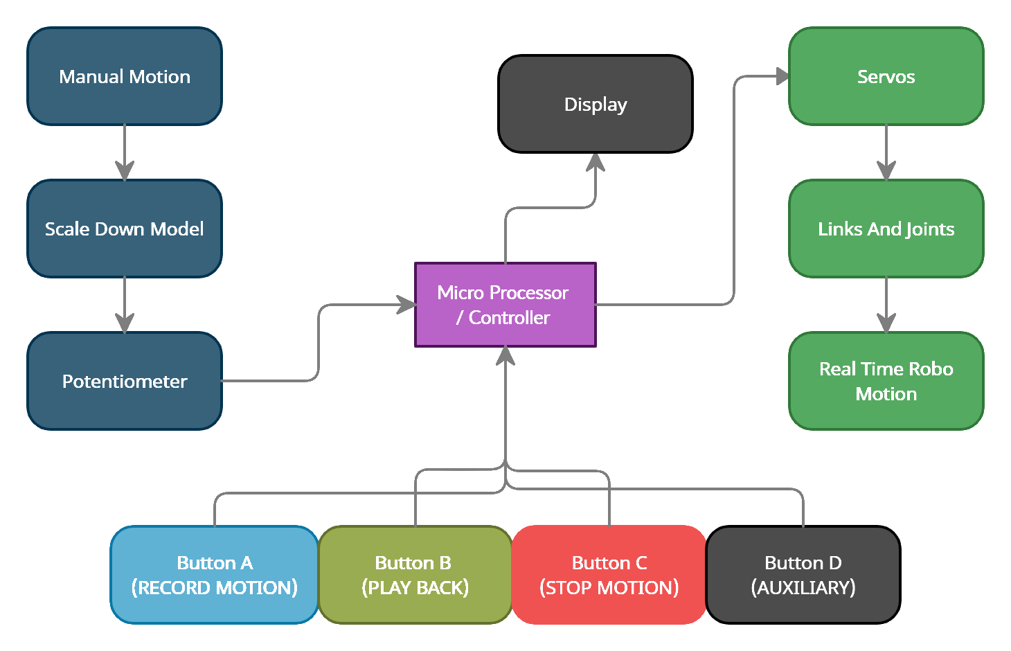

**Fig 3.1: Block diagram of the proposed system**

## DETAILED WORKING DESCRIPTION

Step-1: We going to move the scale down model.

Step-2: The potentiometer is attached to the model will gives the output voltage with reference to the power supply and the angle of the scale down model.

Step-3: These output voltages from each joints of the scale down model are then converted to angles through micro controller.

Step-4: In the real-time robot, we will have servo motors for angular twist of the arm. So we will control the servo through the angles obtained from the microcontroller with data from the potentiometer of the scale down model.

So through programing, we can lively control the real-time robot with a small scale down model.

Later, when we need to record some required motion, we have switches for saving the angles, replay the position and to reset the program memory.

Through display device like computer, we can lively monitor the actions performed by the robot with clear data that can be saved and documented for future references.

.

## DESIGN OF THE PROJECT

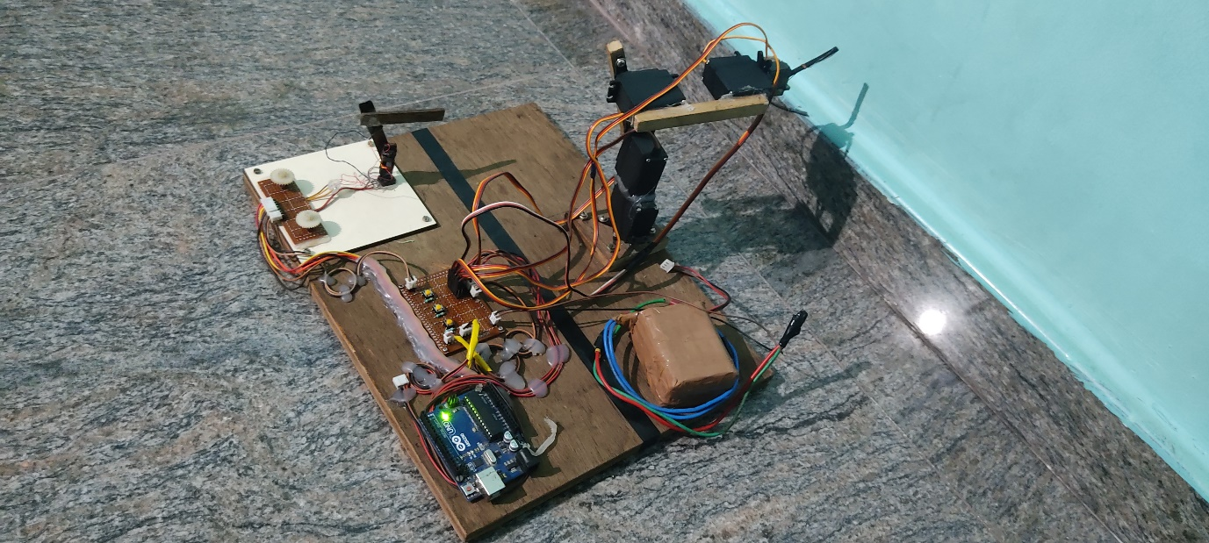

**Fig 3.2: Design of the project**

## INTERCONNECTION OF COMPONENTS:

The five potentiometers are connected from the 5-analog pins A1-A5. The five servos are connected to 5-digital with PWM output pins and the four switches are connected to the digital pins 8, 12 & 13.

The display of results are obtained through the serial monitor through Type-B data cable to display monitor. The board is powered with 7.4V DC made of Li-ion cells in arrangement 2S3P. As each cells are with specification 3.7V, 2.2AH. So the 2S3P will gives the output of 7.4V 6.6AH

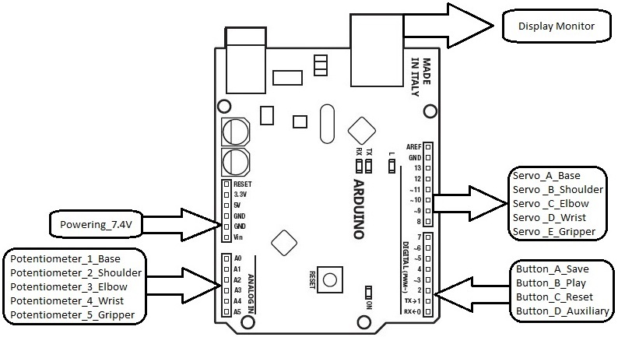

## Fig 3.3: Interconnection diagram

**CHAPTER IV**

**HARDWARE DESCRIPTION**

## ARDUINO UNO:

An open-source microcontroller board based on the Microchip ATmega328P microcontroller and developed by Arduino.cc. The board is equipped with sets of digital and analog input/output (I/O) pins that may be interfaced to various expansion boards (shields) and other circuits. The board has 14 digital I/O pins (six capable of PWM output), 6 analog I/O pins, and is programmable with the Arduino IDE (Integrated Development Environment), via a type B USB cable. It can be powered by the USB cable or by an external supply.

## FEATURES:

* + - * The operating voltage is 5V
      * The recommended input voltage will range from 7v to 12V
      * Digital input/output pins are 14
      * Analog i/p pins are 6
      * DC Current for each input/output pin is 40 mA
      * DC Current for 3.3V Pin is 50 mA
      * Flash Memory is 32 KB
      * SRAM is 2 KB
      * EEPROM is 1 KB
      * CLK Speed is 16

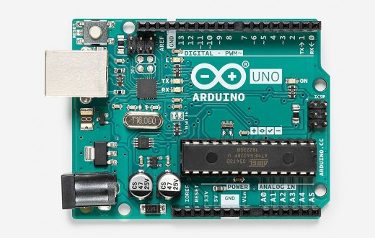

**Fig 4.1 Arduino UNO**

## HIGH TORQUE SERVO MOTOR:

A rotary actuator that allows for precise control of angular or linear position, velocity and acceleration. It consists of a suitable motor coupled to a sensor for position feedback. It also requires a relatively sophisticated controller, often a dedicated module designed specifically for use with servomotors.

Servomotors are not a specific class of motor, although the term servomotor is often used to refer to a motor suitable for use in a closed-loop control system. The servo circuitry is built right inside the motor unit and has a position able shaft, which usually is fitted with a gear. The motor is controlled with an electric signal which determines the amount of movement of the shaft. Inside there is a set-up: a small DC motor, potentiometer, and a control circuit. The motor is attached by gears to the control wheel.

As the motor rotates, the potentiometer's resistance changes, so the control circuit can precisely regulate how much movement there is and in which direction. When the shaft of the motor is at the desired position, power supplied to the motor is stopped. If not, the motor is turned in the appropriate direction.

The desired position is sent via electrical pulses through the signal wire. The motor's speed is proportional to the difference between its actual position and desired position. So if the motor is near the desired position, it will turn slowly, otherwise it will turn fast. This is called proportional control. This means the motor will only run as hard as necessary to accomplish the task at hand, a very efficient little guy.

## APPLICATIONS:

* position control surfaces
* operating grippers
* In food services and pharmaceuticals
* in-line manufacturing
* Automatic doors
* Printing presses
* Solar array and antenna positioning
* Cameras

## FEATURES:

* + - * Weight: 55g
      * Dimension: 40.7×19.7×42.9mm
      * Operating Voltage: 4.8-6.6 V
      * Stall torque @4.8V : 13kg-cm
      * Stall torque @6.6V : 15kg-cm
      * Operating speed @ 4.8V : 0.19sec/60degree
      * Operating speed @ 6.6V : 0.15sec/60degree
      * Angle of rotation: 180 degrees
      * Temperature Range: 0- 55º
      * Servo wire length: 32cm
      * Pulse cycle: 1 mS
      * Gear Type: Metal gear
      * Power Supply: Through External

## COMPARISON TABLE:

**MG995 Metal Gear Servo Motor Vs MG90S Metal Gear Servo Motor**

|  |  |  |
| --- | --- | --- |
| SPECIFICATION | **MG995 Metal Gear Servo Motor** | **MG90S Metal Gear Servo Motor** |
| Weight | 55 gm | 13.4g |
| Dimension | 40.7×19.7×42.9mm | 22.8 × 12.2 × 28.5 mm |
| Operating Speed (4.8V no load) | 0.19sec/60degree | 15sec / 60 deg |
| Operating Speed (6.6V no load) | 0.15sec/60degree | 13sec / 60 deg |
| Stall torque @4.8V | 13kg-cm | 1.8kg-cm |
| Stall torque @ 6.6V | 15kg-cm | 2.2kg-cm |
| Dead band width | 5µs | 5µs |
| Temperature range | 0- 55º | 0- 55º |
| Operation Voltage | 4.8-6.6 V | 4.8-6.6 V |

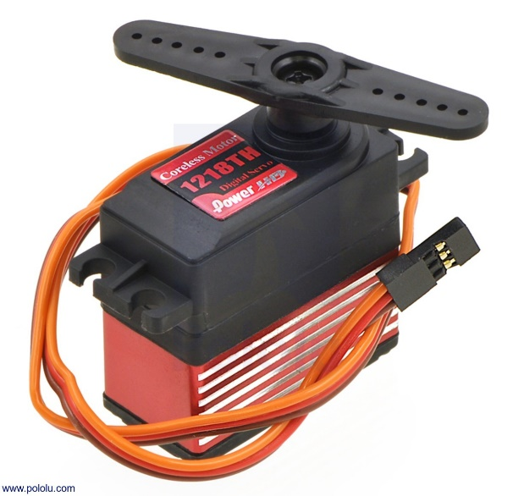

## Fig.4.2: High Torque Servo Motor

* 1. **LM7805 VOLTAGE REGULATOR IC:**

Voltage regulators are very common in electronic circuits. They provide a constant output voltage for a varied input voltage. In our case the 7805 IC is an iconic regulator IC that finds its application in most of the projects. The name 7805 signifies two meaning, “78” means that it is a positive voltage regulator and “05” means that it provides 5V as output. So our 7805 will provide a +5V output voltage.

The output current of this IC can go up to 1.5A. But, the IC suffers from heavy heat loss hence a Heat sink is recommended for projects that consume more current. For example if the input voltage is 12V and you are consuming 1A, then (12-5) * 1 = 7W. This 7 Watts will be dissipated as heat.

## PIN DIAGRAM:

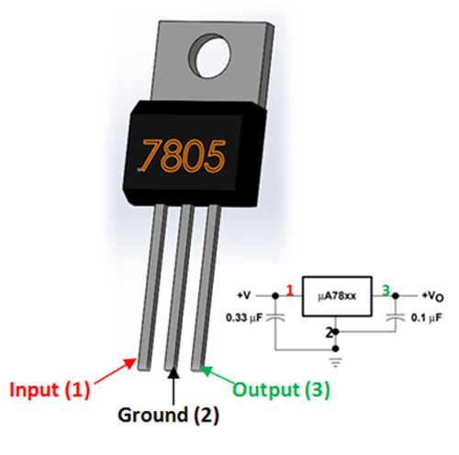

**Fig. 4.3 Pin diagram of LM7805 IC**

s, the 7805 Voltage Regulator IC. A regulated power supply is very much essential for several electronic devices due to the semiconductor material employed in them have a fixed rate of current as well as voltage. The device may get damaged if there is any deviation from the fixed rate.

One of the important sources of DC Supply are Batteries. But using batteries in sensitive electronic circuits is not a good idea as batteries eventually drain out and loose their potential over time. Also, the voltage provided by batteries are typically 1.2V, 3.7V, 9V and 12V. This is good for circuits whose voltage requirements are in that range. But, most of the TTL IC’s work on 5V logic and hence we need a mechanism to provide a consistent 5V Supply. Here comes the 7805 Voltage Regulator IC to the rescue. It is an IC in the 78XX family of linear voltage regulators that produce a regulated 5V as output. 7805 is a three terminal linear voltage regulator IC with a fixed output voltage of 5V which is useful in a wide range of applications. Currently, the 7805 Voltage Regulator IC is manufactured by Texas Instruments, ON Semiconductor, STMicroelectronics, Diodes incorporated, Infineon Technologies, etc.

* 1. **ROTARY POTENTIOMETER:**

A three-terminal resistor with a rotating contact that forms an adjustable voltage divider. Potentiometers consist of a resistive element, a sliding contact (wiper) that moves along the element, If only two terminals are used, one end and the wiper, it acts as a variable resistor or rheostat. The measuring instrument called a potentiometer is essentially a voltage divider used for measuring electric potential (voltage). Potentiometers operated by a mechanism can be used as position transducers.

A potentiometer is a simple knob that provides a variable resistance, which we can read into the Arduino board as an analog value. In this example, that value controls the rate at which an LED blinks. e connect three wires to the Arduino board. The first goes to ground from one of the outer pins of the potentiometer. The second goes from 5 volts to the other outer pin of the potentiometer. The third goes from analog input 2 to the middle pin of the potentiometer.

By turning the shaft of the potentiometer, we change the amount of resistance on either side of the wiper which is connected to the center pin of the potentiometer. This changes the relative "closeness" of that pin to 5 volts and ground, giving us a different analog input. When the shaft is turned all the way in one direction, there are 0 volts going to the pin, and we read 0. When the shaft is turned all the way in the other direction, there are 5 volts going to the pin and we read 1023. In between, analogRead() returns a number between 0 and 1023 that is proportional to the amount of voltage being applied to the pin.

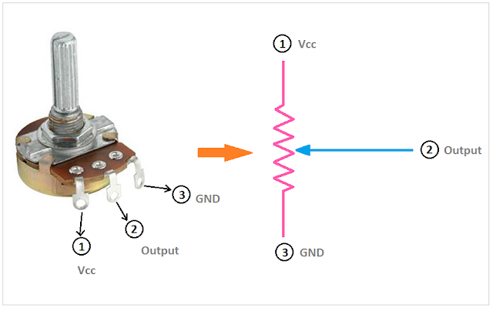

**Fig.4.4: Rotary Potentiometer**

* 1. **USB TO TTL CONVERTER:**

A TTL-USB converter is essentially required for the direct interfacing of modules to the PC, without an intermediate microcontroller or similar platform. We generally use TX and RX pins for communication. We using a Type-2 RS232 TTL signal converter (Tx, Rx, +5V, Gnd). It is a serial with 2-pin connectors for mounting on a microcontroller board. Where, 2-pin connector for power and another 2-pin connector for data. USB to TTL / USB-TTL /STC microcontroller programmer / PL2303 in nine upgrades plate with a transparent cover Compatible with ARDUINO, RASPBERRY PI, AVR, PIC, 8051, etc. The USB to RS232 module based TTL provides the best and convenient way to connect your RS232 TTL Devices or demo board to your PC via the USB port. Adopt imported controller PL2303HX, which can stabilize the flash with high speed, 500mA self-recovery fuse for protection. Two data transmission indicator can monitor data transfer status in real time. Reserve 3.3V and 5V pin interface, easy for the DDWRT of different voltage system that need power. The entire board is coated by high quality transparent heat-shrinkable sleeve, making the PCB in insulation state from outside, so that the board won't burnt down by material short cut. Electrostatic package, insures the board will not be damaged before use.

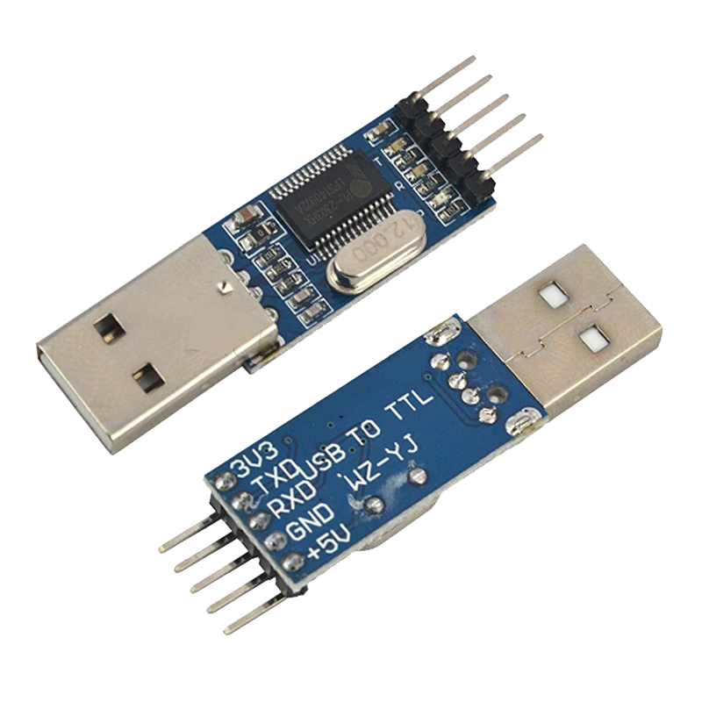

## Fig.4.5: USB to TTL Converter

* 1. **18650-LITHIUM-ION BATTERY:**

A lithium-ion battery or Li-ion battery is a type of rechargeable battery. Lithium-ion batteries are commonly used for portable electronics and electric vehicles and are growing in popularity for military and aerospace applications. Lithium ions move from the negative electrode through an electrolyte to the positive electrode during discharge, and back when charging. Li-ion batteries use an intercalated lithium compound as the material at the positive electrode and typically graphite at the negative electrode. The batteries have a high energy density, no memory effect (other than LFP cells) and low self-discharge. Research areas for lithium-ion batteries include extending lifetime, increasing energy density, improving safety, reducing cost, and increasing charging speed, among others. Research has been under way in the area of non-flammable electrolytes as a pathway to increased safety based on the flammability and volatility of the organic solvents used in the typical electrolyte. During discharge, an oxidation half-reaction at the anode produces positively charged lithium ions and negatively charged electrons. The oxidation half-reaction may also produce uncharged material that remains at the anode. Lithium ions move through the electrolyte, electrons move through the external circuit, and then they recombine at the cathode (together with the cathode material) in a reduction half-reaction. The electrolyte and external circuit provide conductive media for lithium ions and electrons, respectively, but do not partake in the electrochemical reaction. During discharge, electrons flow from the negative electrode (electrons move from the positive electrode to the negative electrode through the external circuit. To charge the cell the external circuit has to provide electric energy. This energy is then stored as chemical energy in the cell (with some loss, e. g. due to coulombic efficiency lower than 1).

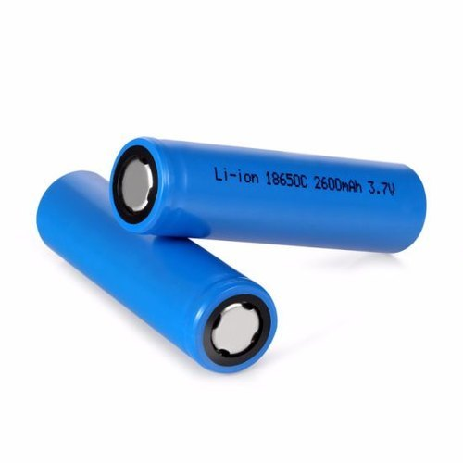

**Fig.4.6: 18650-Lithium-ion battery**

**CHAPTER V**

**SOFTWARE DESCRIPTION**

## ARDUINO IDE:

The Arduino Integrated Development Environment (IDE) is a cross-platform application (for Windows, macOS, Linux) that is written in functions from C and C++. It is used to write and upload programs to Arduino compatible boards, but also, with the help of third-party cores, other vendor development boards.

The source code for the IDE is released under the GNU General Public License, version 2. The Arduino IDE supports the languages C and C++ using special rules of code structuring. The Arduino IDE supplies a software library from the Wiring project, which provides many common input and output procedures. User-written code only requires two basic functions, for starting the sketch and the main program loop, that are compiled and linked with a program stub main() into an executable cyclic executive program with the GNU toolchain, also included with the IDE distribution. The Arduino IDE employs the program avrdude to convert the executable code into a text file in hexadecimal encoding that is loaded into the Arduino board by a loader program in the board's firmware. By default, avrdude is used as the uploading tool to flash the user code onto official Arduino boards.

## WIRED COMMUNICATION:

Wired communication refers to the transmission of data over a wire-based communication technology. Wired communication is also known as wireline communication. Examples include telephone networks, cable television or internet access, and fiber-optic communication. Most wired networks use Ethernet cables to transfer data between connected PCs. Also waveguide (electromagnetism), used for high-power applications, is considered wired line. Local telephone networks often form the basis for wired communications and are used by both residential and business customers in the area. Many networks today rely on the use of fiber optic communication technology as a means of providing clear signaling for both inbound and outbound transmissions and are replacing copper wire transmission. Fiber optic technology is capable of accommodating far more signals than copper wiring while still maintaining the integrity of the signal over longer distances.

## INFRASTRUCTURE:

The Robots will become a part of the fabric of everyday life. It will become part of our overall life just like water, electricity, telephone, TV and most recently the Internet. Whereas the current Internet typically connects full-scale computers, the Internet of Things (as part of the future internet) will connect everyday objects as well as robots with a strong integration into the physical world.

## Plug and control integration:

If we look at advanced lead through technology, we can just make the connection between the real-time robot ad the scale down model. We can lively control them and record the path functions to follow in production.

## Infrastructure functionality:

The infrastructure needs to support the robot applications in finding the work volume. Robots may run anywhere once the path to follow instructions are thought. But if we have proper infra structure, we can make use of the effective work volume with well-defined work functions.

## Physical location and position:

As the robot is strongly rooted in the physical world, the motion parameters and positions are very important, especially for finding exact angles of joints, it is recommendable to use high sensitive hall Effect gimbals in place of potentiometers.

## Security and Protection:

In addition, an infrastructure needs to provide support for security and privacy functions including identification, integrity, confidentiality and authorization. The biometry systems and encryption should be deployed in the control station that enhances the limits of the robot.

## Data management:

It is a crucial aspect in robot programing when considering a world of objects interconnected and constantly exchanging all types of information, the volume of the generated data and the process involved in handling those data becomes critical. We can see the actions performed by the robot in detail through the serial monitor. Also we can record the data and make it a s a log for future reference or to plot the graph of actions performed by that robot graphically. the opportunities of data management are,

* + Data collection and analysis
  + Interval calculation
  + Multi robot networking
  + Virtual process plan
  + Complex operation plan

## BENEFITS OF ADVANCED LEAD THROUGH PROGRAMING:

The Advancement in Lead through programing offers a number of benefits to organizations, enabling them to:

* Need not to monitor their overall actions
* improve the facility
* save time and money
* enhance employee productivity
* integrate and adapt business models
* make better business decisions
* generate more revenue

This encourages companies to rethink the ways they approach their businesses, industries and markets and gives them the tools to improve their business strategies.

## APPLICATIONS:

* Small scale industries
* Low accuracy high precision manufacturing industries
* Hazardous locations
* Waste management
* Incident management system
* Object Tracking
* Hospital management
* Human assistance
* Cooking and serving
* Quality control
* Industry 4.0

## C & C++ LANGUAGE:

The Arduino IDE supports the languages C and C++ using special rules of code structuring. These are an open source programming language which is interpreted and are required to be compiled to run. If the programmer needs to change the code, they can quickly see the results in the serial monitor. It is a high-level language and writing time is not to be considered since after single time perfect programing, we are not going to look back and alter the program. These are flexible and dynamic language that you can use in different ways. It can be used interactively when ones simply want to test a code or a statement.

## CHAPTER VI

## RESULTS AND DISCUSSION

**6.1 RESULTS:**

The robot was tested in three different purposes – one for finding the accuracy and precision another to check the live control and another for pick and place robot programing. The robot was capable of performing any operations that can be achieved inside the work volume with selective end effector and joint drivers. Providing navigation instructions to the robot that learns .the autonomous action of the robot was achieved in these tests.

The programing was executed and the real-time robot is capable of learning the job and to follow the path we instructed through the small model.

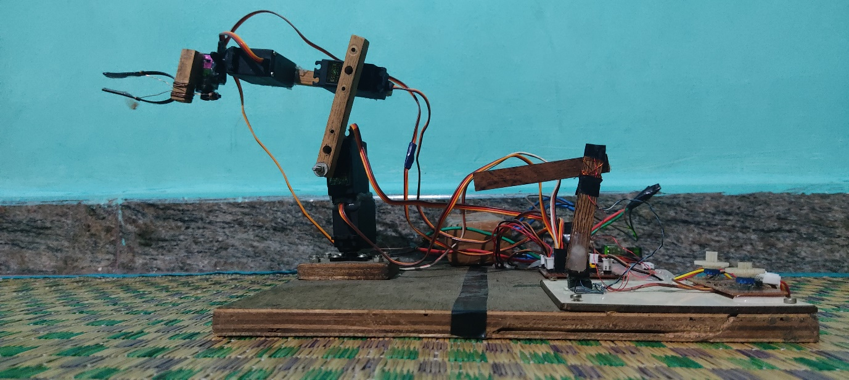

## Fig 6.1: Proposed system

**6.1.1 COMPARISON TABLE:**

**CONVENTIONAL PROGRAMING VS**

**ADVANCED LEAD THROUGH PROGRAMING:**

|  |  |  |
| --- | --- | --- |
|  | **Conventional Programing** | **Advanced lead through programing** |
| **Live control** | Not-possible | Possible |
| **Live control latency** | - | 20mS |
| **Save position delay** | 150mS | 1000mS |
| **Driver type** | Stepper/Servo | Servo |
| **PWM frequency** | Based on driver | 490 Hz |
| **Robot cost** | >60L | <25L |
| **Emergency reset** | <50mS | <100mS |
| **Accuracy** | 1 micron | 800 microns |
| **Precision** | < 0.5mm | <0.70mm |
| **Controller** | Joystick/PC | Scale down model |
| **Suitable Application** | Job machining | Job handling |

The entire system is powered with Li-ion cells. Convientional programing like offline,teachpendent and leadthrough methods are compared with this new method on the table above.

This shows the difference between conventional programing and advanced lead through programing. As per our result, this programing method is highly suitable for low investment material handling purpose that ensures high accuracy and precision parameters.

**6.2 DISCUSSION:**

The system performed the desired functions and the objectives stated were met. With all these operations being performed, it is indeed a low-cost sustainable investment for building the industrial robots for the people and making the quality and variety products with user desirable manner that leads to people to be a better entrepreneur there by the economy will be sustained in industry 4.0.

## CHAPTER VII

## CONCLUSION AND FUTURE WORK

* 1. **CONCLUSION:**

After implementation of the advanced lead through programing, the automation meets the defined objectives. It is easy to use and provides simple user interface. It requires low maintenance, which is also an additional advantage.

The Programing method was mainly developed in the aim of a low-cost project, and this can be developed as a real time huge robots and can serve for the purpose of small and medium scale industries for ease of use with greater FOS.

We hope that this project enables the implementation of robots in small scale industries as the programing simplified.

## FUTURE SCOPE:

The Ditto program has successful outputs, but integration with the system wirelessly remains as the future work of this project.

## REFERENCES

1. Alexander Skoglund,Boyko Iliev,Bourhane Kadmiry,Rainer Palm, ‘Programming by Demonstration of Pick-and-Place Tasks for Industrial Manipulators using Task Primitives’, 2007 International Symposium on Computational Intelligence in Robotics and Automation.

2. Pei-Chi Huang,Aloysius K. Mok, ‘A Case Study of Cyber-Physical System Design: Autonomous Pick-and-Place Robot’ , 2018 IEEE 24th International Conference on Embedded and Real-Time Computing Systems and Applications (RTCSA).

3. Peng Hao; Tao Lu; Yinghao Cai; Shuo Wang, ‘Programming by Visual Demonstration for Pick-and-Place Tasks using Robot Skills’, 2019 IEEE International Conference on Robotics and Biomimetics (ROBIO)

4. Mahmoud Abdelaal,‘A Study of Robot Control Programing for an Industrial Robotic Arm’ 2019 6th International Conference on Advanced Control Circuits and Systems (ACCS) & 2019 5th International Conference on New Paradigms in Electronics & information Technology (PEIT)

5. Chaitanya S. Gajbhiye; Megha G Krishnan; S. Kumaravel; S. Ashok‘Fuzzy — Arduino based control strategy for human safety in industrial robots, 2017 IEEE International Conference on Signal Processing, Informatics, Communication and Energy Systems (SPICES)

6. Luka Peternel; Tadej Petrič; Jan Babič, ‘Human-in-the-loop approach for teaching robot assembly tasks using impedance control interface’, 2015 IEEE International Conference on Robotics and Automation (ICRA).

7. Martin Tykal; Alberto Montebelli; Ville Kyrki, ‘Incrementally assisted kinesthetic teaching for programming by demonstration’, 2016 11th ACM/IEEE International Conference on Human-Robot Interaction (HRI)

8. Christian Kohrt; Anthony Pipe; Gudrun Schiedermeier; Richard Stamp; Janice Kiely, ‘A robot manipulator communications and control framework’, 2008 IEEE International Conference on Mechatronics and Automation

9. Y. Kuniyoshi; M. Inaba; H. Inoue, ‘Learning by watching: extracting reusable task knowledge from visual observation of human performance IEEE Transactions on Robotics and Automation ( Volume: 10, Issue: 6, Dec 1994)

10. Rahul Kumar; Sunil Lal; Sanjesh Kumar; Praneel Chand,’ Object detection and recognition for a pick and place Robot Asia-Pacific World Congress on Computer Science and Engineering

**APPENDIX**

DITTO CODE:

#include <Servo.h>

Servo servo_a; //Base

Servo servo_b; //Shoulder

Servo servo_c; //Elbow

Servo servo_d; //Wrist

Servo servo_e; //Gripper

int pot1; //Base

int pot2; //Shoulder

int pot3; //Elbow

int pot4; //Wrist

int pot5; //Gripper

int servo1[10];

int servo2[10];

int servo3[10];

int servo4[10];

int servo5[10];

int angle1; //Base

int angle2; //Shoulder

int angle3; //Elbow

int angle4; //Wrist

int angle5; //Gripper

int savebutton = 8;

int playbutton=12;

int resetbutton = 13;

int switchpoint =0;

int led=7;

boolean ledon=false;

boolean lastbutton=LOW;

boolean currentbutton=LOW;

int cycle = 0;

void setup()

{

Serial.begin(9600);

pinMode(savebutton, INPUT);

pinMode(playbutton, INPUT);

pinMode(resetbutton, INPUT);

pinMode(7,OUTPUT);

servo_a.attach(5);//gripper

servo_b.attach(6);//roll

servo_c.attach(9);//elbow

servo_d.attach(10);//sholder

servo_e.attach(11);//base

Serial.println("Hi, I am Ditto!");

delay(2000);

Serial.println("You can Control, Record & Play back the motion you needed.");

delay(2000);

Serial.println("");

Serial.println("CAUTION - Please follow the instructions Below...");

delay(3000);

Serial.println("");

Serial.println("Press Button-A to Record currect position of Ditto. (Must Record 10 Positions to Playback)");

delay(5000);

Serial.println("Press Button-B to Playback the recorded motion.");

delay(3000);

Serial.println("Press & Hold Button-C to Reset the motion. (Must complete a play cycle)");

delay(5000);

Serial.println("Press Button-D for Emergency stop and Program reboot.");

delay(3000);

Serial.println("");

Serial.print("Connecting.");

delay(400);

Serial.print(".");

delay(400);

Serial.print(".");

delay(400);

Serial.print(".");

delay(400);

Serial.print(".");

delay(400);

Serial.println(".");

delay(400);

Serial.println("Live Control Is Activated.");

delay(2000);

}

boolean debounce (boolean last)

{

boolean current = digitalRead(playbutton);

if(last!=current)

{

delay(5);

current= digitalRead(playbutton);

}

return current;

}

void(* resetFunc) (void) = 0;

void loop()

{

currentbutton=debounce(lastbutton);

if(lastbutton==LOW&&currentbutton==HIGH)

{

ledon=!ledon;

}

lastbutton=currentbutton;

digitalWrite(led,ledon);

//Base

pot1=analogRead(A1);

angle1=map(pot1,0,1023,180,0);

servo_a.write(angle1);

//Shoulder

pot2=analogRead(A2);

angle2=map(pot2,0,1023,180,0);

servo_b.write(angle2);

//Elbow

pot3=analogRead(A3);

angle3=map(pot3,0,1023,180,0);

servo_c.write(angle3);

//Wrist

pot4=analogRead(A4);

angle4=map(pot4,0,1023,60,170);

servo_d.write(angle4);

//Gripper

pot5=analogRead(A5);

angle5=map(pot5,0,1023,0,100);

servo_e.write(angle5);

if(digitalRead(savebutton) == HIGH)

{

switchpoint++;

switch(switchpoint)

{

case 1:

servo1[0] = angle1;

servo2[0] = angle2;

servo3[0] = angle3;

servo4[0] = angle4;

servo5[0] = angle5;

Serial.println("");

Serial.println("Position 1 out of 10 is Saved");

delay(1000);

break;

case 2:

servo1[1] = angle1;

servo2[1] = angle2;

servo3[1] = angle3;

servo4[1] = angle4;

servo5[1] = angle5;

Serial.println("Position 2 out of 10 is Saved");

delay(1000);

break;

case 3:

servo1[2] = angle1;

servo2[2] = angle2;

servo3[2] = angle3;

servo4[2] = angle4;

servo5[2] = angle5;

Serial.println("Position 3 out of 10 is Saved");

delay(1000);

break;

case 4:

servo1[3] = angle1;

servo2[3] = angle2;

servo3[3] = angle3;

servo4[3] = angle4;

servo5[3] = angle5;

Serial.println("Position 4 out of 10 is Saved");

delay(1000);

break;

case 5:

servo1[4] = angle1;

servo2[4] = angle2;

servo3[4] = angle3;

servo4[4] = angle4;

servo5[4] = angle5;

Serial.println("Position 5 out of 10 is Saved");

delay(1000);

break;

case 6:

servo1[5] = angle1;

servo2[5] = angle2;

servo3[5] = angle3;

servo4[5] = angle4;

servo5[5] = angle5;

Serial.println("Position 6 out of 10 is Saved");

delay(1000);

break;

case 7:

servo1[6] = angle1;

servo2[6] = angle2;

servo3[6] = angle3;

servo4[6] = angle4;

servo5[6] = angle5;

Serial.println("Position 7 out of 10 is Saved");

delay(1000);

break;

case 8:

servo1[7] = angle1;

servo2[7] = angle2;

servo3[7] = angle3;

servo4[7] = angle4;

servo5[7] = angle5;

Serial.println("Position 8 out of 10 is Saved");

delay(1000);

break;

case 9:

servo1[8] = angle1;

servo2[8] = angle2;

servo3[8] = angle3;

servo4[8] = angle4;

servo5[8] = angle5;

Serial.println("Position 9 out of 10 is Saved");

delay(1000);

break;

case 10:

servo1[9] = angle1;

servo2[9] = angle2;

servo3[9] = angle3;

servo4[9] = angle4;

servo5[9] = angle5;

Serial.println("Position 10 out of 10 is Saved");

Serial.println("");

Serial.print("Preparing.");

delay(400);

Serial.print(".");

delay(400);

Serial.print(".");

delay(400);

Serial.print(".");

delay(400);

Serial.println(".");

delay(400);

Serial.println("Ready to play.");

delay(1000);

break;

}

}

if(digitalRead(led) == HIGH)

{

Serial.println("");

Serial.print("Play Cycle-");

cycle = cycle+1 ;

Serial.println(cycle);

for(int i = 0; i < 10; i++)

{

Serial.print("Possition ");

Serial.print(i+1);

Serial.print(" ---> ");

{

servo_a.write(servo1[i]);

Serial.print("Base->");

Serial.print(servo1[i]);

Serial.print(" ");

servo_b.write(servo2[i]);

Serial.print("Shoulder->");

Serial.print(servo2[i]);

Serial.print(" ");

servo_c.write(servo3[i]);

Serial.print("Elbow->");

Serial.print(servo3[i]);

Serial.print(" ");

servo_d.write(servo4[i]);

Serial.print("Wrist->");

Serial.print(servo4[i]);

Serial.print(" ");

servo_e.write(servo5[i]);

Serial.print("Gripper->");

Serial.print(servo5[i]);

Serial.println("");

}delay(1000);

}

}

if(digitalRead(resetbutton) == HIGH)

{

delay(100);

Serial.println("");

Serial.print("Processing...");

Serial.print(".");

delay(500);

Serial.print(".");

delay(500);

Serial.println(".");

delay(500);

Serial.println("reset complete");

Serial.println("");

delay(1000);

resetFunc();

}

}